**S/18/335 - Individual Assignment**

**Explain the use of SVM for data points that are not separable by a linear decision surface, using the**

**XOR function (exclusive OR), which takes a value of 0 when both inputs are the same and takes a value**

**of 1 otherwise.**

**Explain your answer using illustrations.**

**Work in your groups to discuss and submit your answers individually.**

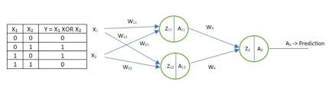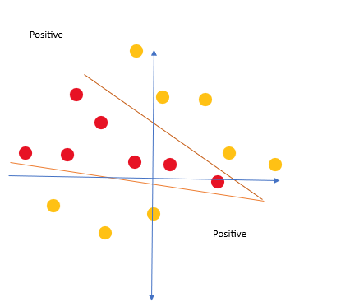

There are some of the cases where there is no clear division between the points which makes it non - linear and we cannot divide the plane by using only one decision boundary at some of the cases we can do it by using two decision boundaries which divides the regions to positive and negative on ,

(0, 0) labeled as 0 (negative class)

(0, 1) labeled as 1 (positive class)

(1, 0) labeled as 1 (positive class)

(1, 1) labeled as 0 (negative class) which makes it like a XOR gate which uses two neurons in the actual architecture to give the decision.